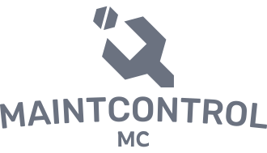
Students
Lior Fridman
206798902
Matan Avital
204597082
Reuven Bar
316043652
Nave Shimoni
207382987
PM
Tal Gumai
Our methodology involves developing a responsive web application using REACT for both desktop and mobile devices, with data reception and storage achieved through a SQL relational database based on Postgres, which will store system parameters, user details, and other settings.

- Daily missions
- Task page
- Mission's history
- Admin users management

- Login page
- Reset password
- Sign up
- Guides
- User's information(location, role, company, etc.)

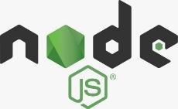

Our web-based system offers a promising approach to improve maintenance operations. By optimizing task management, scheduling and reporting, the system enhances efficiency and coordination. Successful implementation and user adoption will be key to realizing the system's potential in streamlining workflows and improving productivity in the maintenance industry.
The goal of the project is developing a versatile web-based system that addresses the challenge of supervising and controlling maintenance activities conducted by multiple companies across various locations in the country. By doing so, we aim to optimize the daily workflow of maintenance workers.
Problem
Inadequate supervision and control over maintenance activities conducted by companies.
Solution
Optimized web app designed to streamline and enhance the daily work of maintenance personnel.
Task Management ● Scheduling and Calendar ● Equipment Management
Reporting and Documentation
MaintControl
Hit Project

